FLASHCARD DATA FOR NATURE OF KINSHIP

Topic 1: Overview

1. | The term for culturally defined relationships between individuals who are commonly thought of as having family ties. | kinship
2. | The general term for socially recognized links between ancestors and descendants. | descent (or descent bond)
3. | The kind of kinship bond that links husband or wife, mother-in-law, father-in-law, brother-in-law, and sister-in-law. | affinity (or marriage) bond
4. | The formal kinship analysis term for people who are related by bonds of affinity. | affines (or affinal relatives)
5. | The kind of kinship bond that links people through socially recognized biological ties, such as mother, father, grandparents, children, grandchildren, uncles, aunts, brothers, sisters, and cousins. | consanguinity
6. | The formal kinship analysis term for people who are related by bonds of consanguinity. | consanguines (or consanguinal relatives)
7. | The term for a socially recognized link between individuals, created as an expedient for dealing with special circumstances, such as the bond between a godmother and her godchild. These bonds are based on friendship and other personal relationships rather than marriage or descent. | fictive kinship
8. | The kind of kin term used when addressing someone directly in contrast to when they are referring to them in a conversation with someone else. | term of address
9. | The kind of kin term used when referring to someone in a conversation with someone else. | term of reference
10. | The kind of kinship bond that links parents to their adopted children. | fictive kinship
11. | A fictive kinship term used for godparents among Spanish speakers in Latin America. | comadre (co-mother) or compadre (co-father)

Topic 2: Descent Principles: Part I

1. | The gender of a person who is represented by a triangle in kinship diagrams. | male
2. | The gender of a person who is represented by a square in kinship diagrams. | either male or female
3. | In kinship diagrams, the term that is used to label the person to whom all kinship relationships are referred. | ego
4. | What an equals sign (=) represents in kinship diagrams. | marriage bond between a husband and his wife
5. | What a vertical line represents in kinship diagrams. | bond of descent (e.g., parent-child bond)
6. | The general descent principle in which kinship is traced only through a single line of ancestors, male or female. Both males and females are members of a family, but descent links are only recognized through relatives of one gender. | unilineal descent
7. | The descent principle in which kinship is traced only through the male line. With this pattern, people are related if they can trace descent through males to the same male ancestor. Both males and females inherit family membership but only males can pass it on to their descendants.  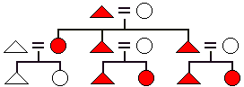 | patrilineal descent
8. | The descent principle in which kinship is traced only through the female line. With this pattern, people are related if they can trace descent through females to the same female ancestor. Both males and females inherit family membership but only females can pass it on to their descendants.  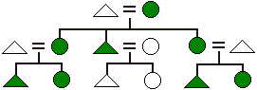 | matrilineal descent
9. | In societies using matrilineal descent, the man who most likely would have the formal kinship related responsibilities for a boy that European cultures assign to his father. | his mother’s brother (or maternal uncle)  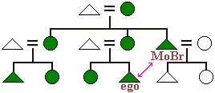
10. | The family member from whom a woman will most likely inherit wealth, titles, or other status in a society with matrilineal descent. | her mother
11. | The family member from whom a man will most likely inherit wealth, titles, or other status in a society with patrilineal descent. | his father
12. | The male family member from whom a man will most likely inherit wealth, titles, or other status in a society with matrilineal descent. | his mother’s brother (or maternal uncle)
13. | The kinds of subsistence patterns of societies which are most likely to use unilineal descent. (Hint: all are societies with small populations that usually have more than adequate food supplies.) | materially rich foragers, small-scale farmers, and nomadic pastoralists
14. | The general descent principle that about 60% of all societies used to trace descent until the early 20th century. (Hint: most of these societies had small numbers of people.) | unilineal descent
15. | The term for the variation of cognatic descent in which both patrilineal and matrilineal descent lines are recognized. In this rare system, there are two direct ancestors in each generation—a male one and a female one.)  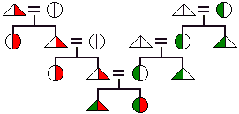 | bilineal descent (or double descent)
16. | The descent system which results in only one direct ancestors in each generation. | unilineal (patrilineal or matrilineal)
17. | The term for the variation of cognatic descent in which men trace their ancestry through male lines and women trace theirs through female lines. (Hint: unlike bilineal descent, each individual is a member of only one descent group.)  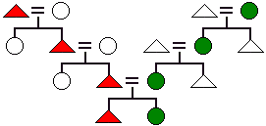 | parallel descent
18. | The term for the descent system in which individuals may select only one unilineal line to trace descent (male or female). Since each generation can choose which parent to trace descent through, a family line may be patrilineal in one generation and matrilineal in the next.  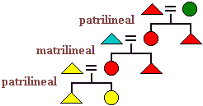 | ambilineal descent

Topic 3: Descent Principles: Part II

1. | The cognatic descent system that is commonly used in North America and Europe today. | bilateral descent
2. | The descent system in which all male and female children are members of both their father's and mother's families.  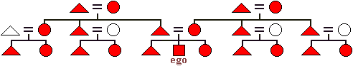 | bilateral descent
3. | The descent system that is used most commonly by large agricultural and industrial nations as well as by hunters and gatherers in harsh, relatively nonproductive environments such as deserts and arctic wastelands. | bilateral descent
4. | The number of direct ancestors in each generation back through time that potentially exist with bilateral or cognatic descent. | two parents and double the number of ancestors each generation back (i.e., 2, 4, 8, 16, etc.)
5. | The descent system in which there are the least possible number of ancestors per generation—i.e., there is only one ancestor per generation. | unilineal (patrilineal or matrilineal) descent
6. | The descent system in which there are the most possible number of ancestors per generation. | bilateral descent
7. | The descent system that can result in the largest number of possible descendants after 4 generations. Assume that in all descent systems that you are thinking of that everyone has exactly 4 children and that they all live to have 4 children. (Hint: there will be a total of 256 offspring with the descent system that has the most potential descendants.) | bilateral descent

Topic 4: Descent Groups

1. | The term for a family consisting of a man, woman, and their children. | nuclear family
2. | The term for the nuclear family into which one is born. | family or orientation
3. | The term for the nuclear family in which one is a parent. | family of procreation
4. | The term for a nuclear family in which there is no continuing adult male functioning as a husband/father. In such families, the mother raises her children more or less alone and subsequently has the major role in their socialization.  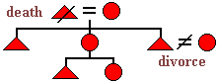 | matricentric (or matrifocused)
5. | The general term for a multi-generational group of relatives who are related by unilineal descent. (Hint: the answer is not dependent on whether the descent pattern is matrilineal or patrilineal.) | unilineage
6. | A multi-generational group of relatives who are related by patrilineal descent. This large family group usually consists of a number of related nuclear families descended from the same man. | patrilineage
7. | A multi-generational group of relatives who are related by matrilineal descent. This large family group usually consists of a number of related nuclear families descended from the same woman. | matrilineage
8. | A group of people who claim unilineal descent from the same ancestor but who cannot specify all of the actual links. The ancestor is genealogically so remote that he or she is often thought of as a mythical being, animal, or plant. This type of large family group usually consists of a number of related unilineages. | clan
9. | A unilineal descent group consisting of a number of related clans. This very large family group’s founding ancestor is so remote genealogically that he or she is usually mythical. | phratry
10. | One of two unilineal divisions of an entire society. These very large family groups have reciprocal privileges and obligations with each other, such as providing marriage partners and assisting at funerals. The founding ancestor of each of these groups is often so genealogically remote that he or she is now mythical. | moiety
11. | The term that anthropologists use for a fictional clan originator. (Hint: the term came from the huge poles carved by Indians on Vancouver Island in Western Canada to represent their mythical ancestors.) | totem (or totemic emblem)
12. | The region of the world in which the Kariera four class system of patrilineal descent combined with moieties was traditionally used. | Western Australia (among the aborigines)
13. | The term for a group of relatives who are linked together by a single individual who can trace descent and/or marriage relationships to every other member of the family. (Hint: this is usually the largest family group formed in societies using bilateral or cognatic descent.) | kindred
14. | The thing that usually prevents North American kindreds from functioning as efficiently as unilineages in collective ownership and mutual aid. | conflicting interests and obligations of different family members (especially in-laws)
15. | The only kind of bilateral, or cognatic, kindred that regularly continues to exist after the death of its founder. | a dead ancestor focused kindred

Topic 5: Kin Naming Systems: Part I

1. | The name for the most common kin naming system in North America and Europe today. | Eskimo
2. | The kin naming system in which cousins are lumped together and given the same kin name, while siblings are distinguished from cousins and given gender specific kin names as illustrated below.  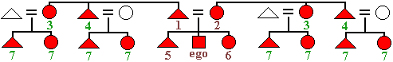 | Eskimo
3. | The descent pattern of most societies that use the Eskimo kin naming system. | bilateral (or cognatic) descent
4. | The two kin naming systems in which both ego's mother's and father's collateral relatives are considered equally important. That is to say, no distinction is made between relatives on the mother's and father's side of the family. This is reflected in the use of the same gender specific kin names for them. | Eskimo and Hawaiian
5. | The number of different basic kin naming systems used around the world. | six
6. | The kinds of societies that use the Eskimo kin naming system. (Hint: the common denominator for these societies is an economy that forces the nuclear family to be mostly independent.) | most technologically complex societies and foragers living in harsh environments
7. | The least complex kin naming system. (Hint: this system uses only four different kin terms of reference.) | Hawaiian
8. | The kin naming system in which relatives are distinguished only by generation and gender (e.g., ego's father and all male relatives in his generation have the same kin name, and ego's mother and all female relatives in her generation are referred to by the same kin term as illustrated below.)  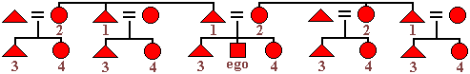 | Hawaiian
9. | The region of the world where the Hawaiian kin naming system is most commonly used. | Polynesia (islands of the South Central Pacific Ocean)
10. | The most complex kin naming system. (Hint: with this system, most kinsmen are not lumped together under the same terms of reference. Each category of relative is given a distinct term based on genealogical distance from ego and on the side of the family. There can be eight different cousin terms, all of whom are distinguished from ego's brother and sister as illustrated below.)  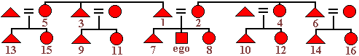 | Sudanese
11. | The kin naming system that has been traditionally used most commonly in Sudan and Turkey. (Hint: these are societies with patrilineal descent and considerable complexity in terms of social class and political power.) | Sudanese
12. | The general term for a culturally defined set of rules for terms of address and reference to be used for specific categories of relatives. (Hint: there are 6 types of these systems used around the world.) | kin naming system (or kin terminological system)

Topic 6: Kin Naming Systems: Part II

1. | The three kin naming systems named after North American Indian cultures. | Omaha, Crow, and Iroquois
2. | The general kinship term for a cousin who is ego's father's brother's children or mother's sister's children. (Hint: the gender of the cousin is not relevant in making this distinction.) | parallel cousin
3. | The general kinship term for a cousin who is ego's father's sister's children or mother's brother's children. (Hint: the gender of the cousin is not relevant in making this distinction.) | cross cousin
4. | The cousins who would be considered relatives in a society with unilineal descent. (Hint: think in terms of cross and parallel cousins. The answer will be the same for patrilineal and matrilineal descent.) | parallel cousins
5. | The descent pattern of societies that use the Omaha kin naming system. (Hint: think in terms of patrilineal, matrilineal, bilateral, etc.) | patrilineal descent
6. | The descent pattern of societies that use the Crow kin naming system. (Hint: think in terms of patrilineal, matrilineal, bilateral, etc.) | matrilineal descent
7. | The kin naming system that is almost a mirror of the Omaha system. (Hint: in both systems, siblings and parallel cousins of the same gender are given the same term of reference, and other relatives not in ego's unilineage are lumped across generations in regards to kin terms.) | Crow
8. | The kin naming system in which the same term of reference is used for father and father's brother as well as mother and mother's sister. (Hint: this merging is related to shared membership in unilineages, as it is in the Omaha and Crow systems. However, this system may be either patrilineal or matrilineal and is usually not as strongly one or the other.)  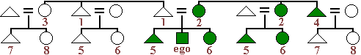 | Iroquois
9. | The kin naming system in which siblings and parallel cousins from both sides of the family are distinguished only by gender in terms of reference. Cross cousins are also lumped together and distinguished by gender. | Iroquois
Copyright © 2007 by Dennis O'Neil. All rights reserved.

